**Swinburne University of Technology**

Ho Chi Minh Campus

COS30043

Project Report : Custom Web Application

Student : Nguyen Quoc Thang

ID : 104193360

I . Introduction

This document outlines the design and development of a single-page web application used to allow users to make, view, and delete reservation records, as well as search their past reservation history. The frameworks used to create the user interface for this project are Vue.js and Bootstrap.

II . Requiremnet

Function requirement

* The application has four main functionalities:
* Making reservations: Users can fill out a form to make a reservation, providing details such as their name, email, phone number, date/time, and number of people.
* Viewing reservation history: Users can view a list of all their past reservations.
* Deleting reservations: Users can delete a reservation from the list if they no longer need it.
* Login and registration: Allows users to access the website if they have an account, and requires them to register for a new account if they do not.

My website also utilizes techniques to ensure responsiveness. It can automatically adjust the layout to suit the screen size of various device types, making it easy for users to access the website whether they are using a computer, mobile phone, or tablet. Not only that, this application is designed with a clear and intuitive user interface to help users search for the list of table booking history they need to find.

III. Technical Aspects

1. Technologies Used

* Vuejs: an open source Javascript framework used to build user interfaces. It provides a component-based and declarative programming model that enables us to develop user interfaces easily, efficiently, and flexibly.
* Bootstrap : Is an open CSS framework that allows users to design reasonable, friendly and responsive user interfaces for web applications.
* Vuejs Router : Used to manage routing in the application
* Vuex : Used to manage application state

1. Component Structure

* AddResource : The component contains a form for reservations
* LearningResource : Component used to display each reservation
* StoredResource : Component used to display the reservation list
* TheResource : Component to convert between Booking Form and Booking History
* HomePage : Hiện thị trang chính của trang
* TheLogin : The component is used to interface and authenticate user input
* TheRegister : The component is used to display the registration interface and validate data when the user registers
* TheHeader : Displays the navigation bar on top of the page

IV. Innovative Features

* Dynamic components: Ability to switch between AddResource and StoredResource based on user interaction, helping to optimize performance and enhance user experience
* Vuex state management: Used to manage the application's state, I use it to update the state in the application's login and logout

V. Screenshot

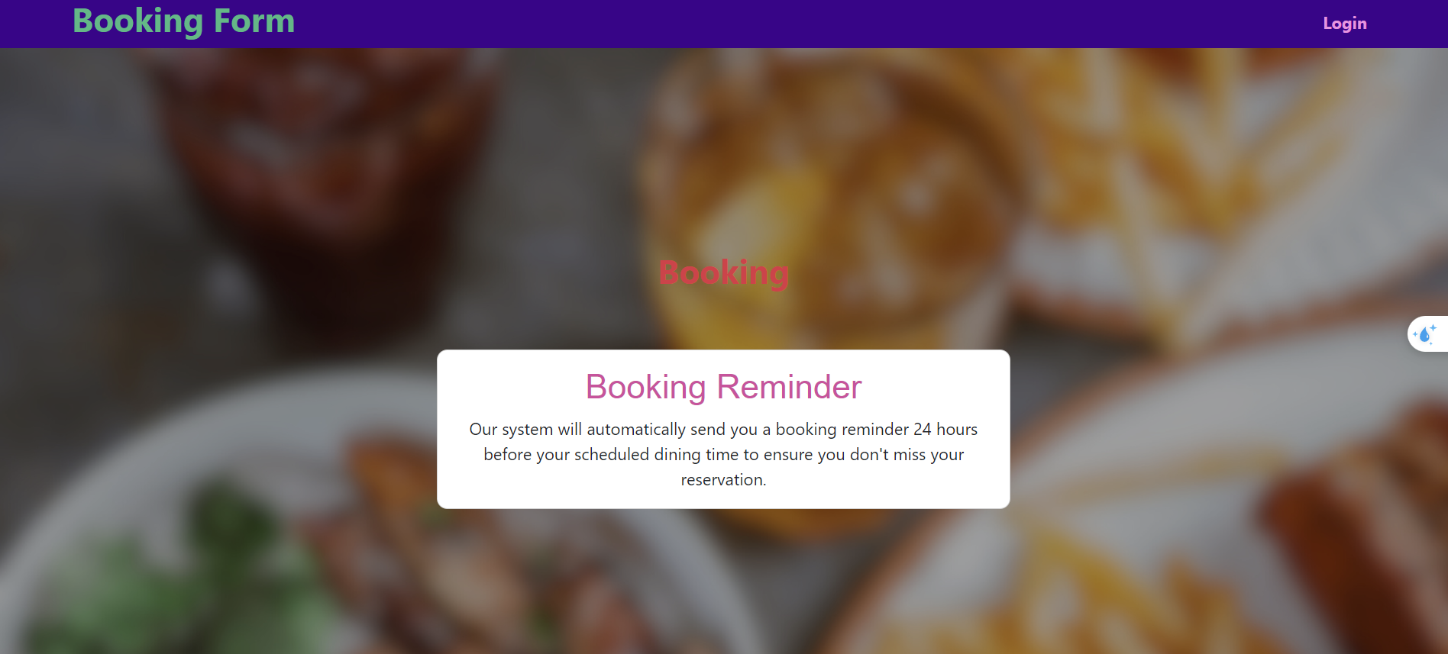

*Image 1 : Home Page*

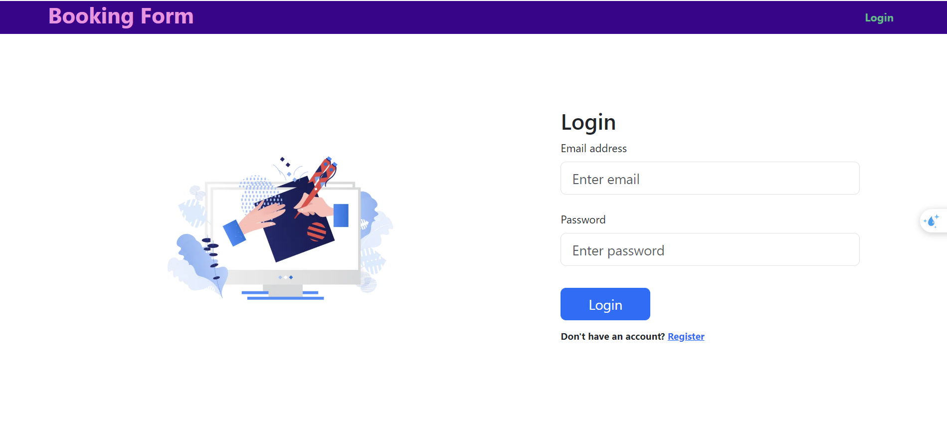

*Image 2 : Login Page*

*Image 3 : Register Page*

*Image 4 : Booking History Page*

*Image 5 : Booking Form*